 | BAHRIA UNIVERSITY, (Karachi Campus)  Department of Software Engineering  Assignment 1 - Fall 2021

COURSE TITLE: Introduction to Media Studies COURSE CODE: HSS 115
Class: BSC 3B Shift: Morning
Course Instructor: Najeeha Rahman Time Allowed: 1 Week
Submission Date: 1/11/21 Max. Marks: 10 Marks
Name : Muhammad Junaid Saleem Qadri Enrollment No: 02-131202-057

Question No. 1 [CLO4: 10 Marks]

Creative/Narrative Writing Assignment

Tasks which will stimulate students’ creativity to write a pitch document for a fictional story of a
short film. Apply Three act structure/Story arc and show how the story changes as a result.
Expand the back-story of the characters and make it into a separate story (if needed), outline,
storyboard, or write a sequel.

This activity covers elements of three major creative writing genres:
Short story, narrative essay, and memoir. You will master the techniques that good writers use
to compose a bracing story, populated with memorable characters in an interesting setting,
written in a fresh descriptive style. You will analyze and constructively evaluate peer writing. In
the Capstone, you will draft, rewrite, and complete a substantial original story in the genre of
you’re choosing.

The submission must also include synopsis, plot summary, story arc and character sketches of all characters in the story.

The Toy Story

ACT I:
Woody is the leader of the toys in Andy’s Room.

Inciting Incident: Andy gets a new toy at his birthday party: Buzz Lightyear! All the toys are dazzled. Woody gets jealous. That’s Plot Point 1.

ACT II:
Woody tries to get rid of Buzz, which pisses off the other toys. Mom takes the kids to Pizza Planet; she stops for gas, and then drives away while Woody and Buzz are arguing. Woody and Buzz are now alone out in the wider world, separated from Andy and the other toys. Stakes ratcheted! That’s Pinch 1.

They make it to Pizza Planet and end up getting pulled out of the Claw machine by Syd, who takes them home to “play.” Midpoint (and a low point).

Woody and Buzz realize they are in deep trouble: the toys in Syd’s room are scary as hell; Syd tortures Woody; Buzz sees a TV commercial advertising Buzz Lightyear dolls; doesn’t want to believe it; tries to fly; fails and breaks his arm off in the process. Stakes ratcheted! That’s Pinch 2.
Existential crises for both Woody – ‘cause he’s old – and Buzz – ‘cause he’s not a Space Ranger. Hey, they have something in common! And they reconcile. YAY! But Syd decides to strap first Buzz, and then Woody instead, to a bottle rocket. BOO! Oh, and Andy’s family is moving today, and the moving van arrives. That is what we call a ticking clock: if Woody and Buzz can’t escape Syd before Andy’s family leaves for their new house, they’ll lose their kid forever. This is the low point of the movie. Plot Point 2.

Act III :

Escape from Syd’s house. Woody and Buzz and Syd’s toys “come alive” and freak the hell out of Syd! YAY! But the moving truck and Mom’s car leave for the new house without them! BOO!
They chase Andy’s family using RC (Remote Control) Car. Realizing he still has the bottle rocket strapped to his back, Woody lights the rocket; he and Buzz fly into the sky – or at least fall with style – and land in Mom’s car, next to Andy. All’s well that ends well… except for the puppy.

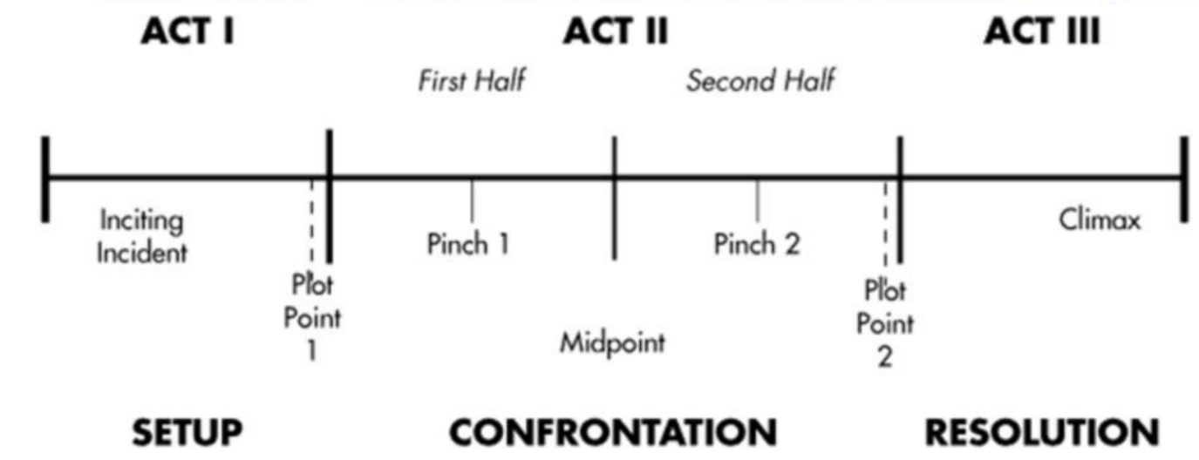

The Toy Story Background

Ever wonder what toys do when people aren't around? Toy Story answers that question with a fantastic fun-filled journey, viewed mostly through the eyes of two rival toys – Woody, the lanky, likable cowboy, and Buzz Lightyear, the fearless space ranger. Led by Woody, Andy's toys live happily in his room until Andy's birthday brings Buzz Lightyear onto the scene. Afraid of losing his place in Andy's heart, Woody plots against Buzz.

But when circumstances separate Buzz and Woody from their owner, the comically-mismatched duo eventually learn to put aside their differences, and they find themselves on a hilarious adventure-filled mission where the only way they can survive is to form an uneasy alliance.

Toy Story Characters

Woody
Sheriff Woody is a cowboy doll. As the toys' leader, and despite his fears to the contrary, he's always been Andy's favorite. Woody is a traditional kind of toy, with his pull-string voice box and cowboy detailing. He has long enjoyed a place of honor as the favorite among six-year-old Andy's toys—until Buzz Lightyear crash-lands and shakes up his world.

Buzz Lightyear
This space ranger action figure has it all: a laser beam, karate-chop action, pop-out wings, and a belief that he's on a secret mission for Star Command. Much to Woody's chagrin, Buzz monopolizes Andy's attention and becomes an instant favorite with his toy mates.

Andy
Andy is portrayed as being an eager, imaginative boy who lives with his mother and younger sister Molly. He is 6 years old in his debut and is the owner of Woody, Buzz Lightyear, and the other toys, which he treats with a large amount of love.

Andy's House
Andy’s room was a world of its own, home to most of Toy Story’s characters and a place that immediately conveyed comfort and safety. That sense of safety provided the conflict as the characters faced new anxieties like leaving the house and welcoming a new toy.

Syd:
Sid is Andy's sociopathic 11-year-old next door neighbor. Syd Philips is the main antagonist of the Toy Story. He is the only human character who knows that the toys are alive. He loves destroying and torturing toys, and the evidence can be seen by his toys. He wears a shirt with a cartoon-like skull design. In addition to actively destroying toys, Sid enjoys skateboarding. When he witnessed toys coming to life and his turning against him to rescue Buzz Lightyear, Syd developed a fear of toys

Pizza Planet
In an early version of the film, the pizza parlor had a miniature golf theme. When Buzz Lightyear entered the picture, the Pixar designers turned it into Pizza Planet, an elaborate space-themed drive-in that Buzz could mistake for a spaceport and his ticket home. It also supplied the name and logo for the Pizza Planet delivery truck, which went on to make cameos in several Pixar films.

Claw machine:
The Claw referred to by the Aliens, is part of a rocket ship crane game (also called "Space Crane") inside Pizza Planet.

Summary

Toy Story is about the 'secret life of toys' when people are not around. When Buzz Lightyear, a space-ranger, takes Woody's place as Andy's favorite toy, Woody doesn't like the situation and gets into a fight with Buzz. Accidentally Buzz falls out the window and Woody is accused by all the other toys of having killed him. He has to go out of the house to look for him so that they can both return to Andys room. But while on the outside they get into all kind of trouble while trying to get home.

